Block G
Students | Molecule
Block G partner: Renton | 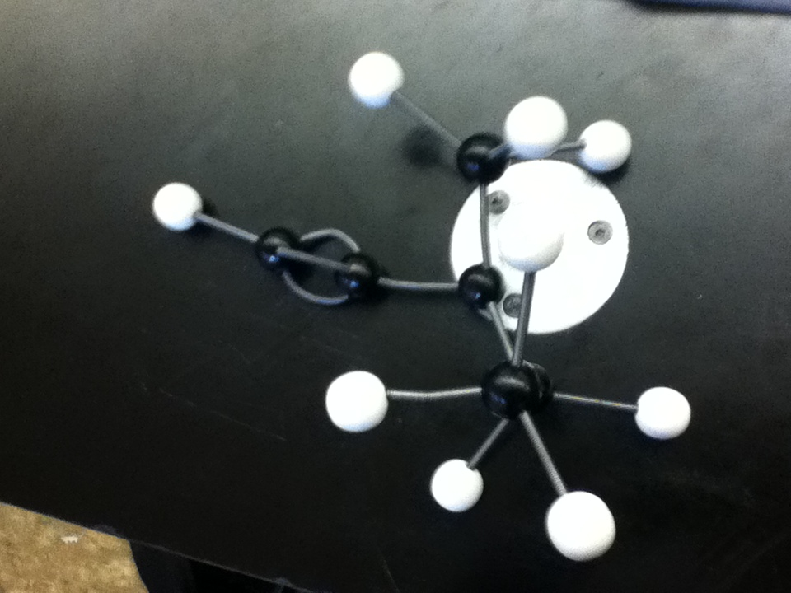
Sarah and milos | 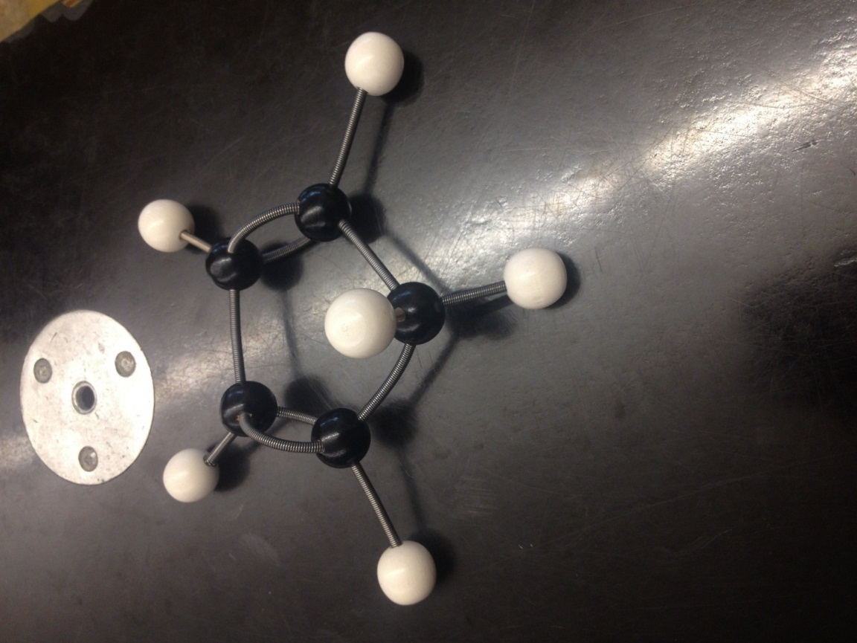
BlockG partners: Johnny luo and jerret | 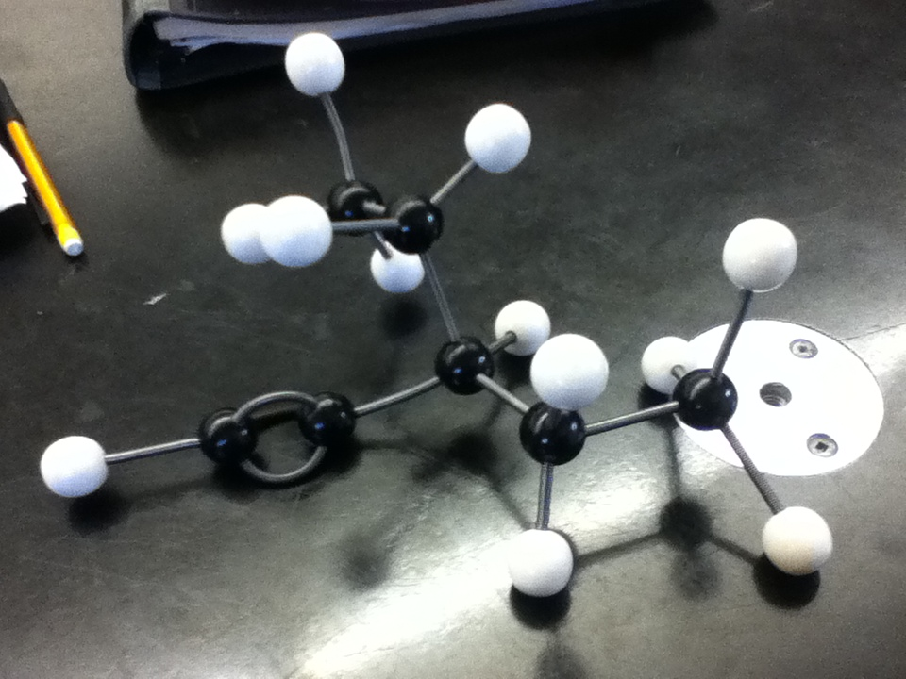
Vivian Vuong and Melissa Tse Block G | 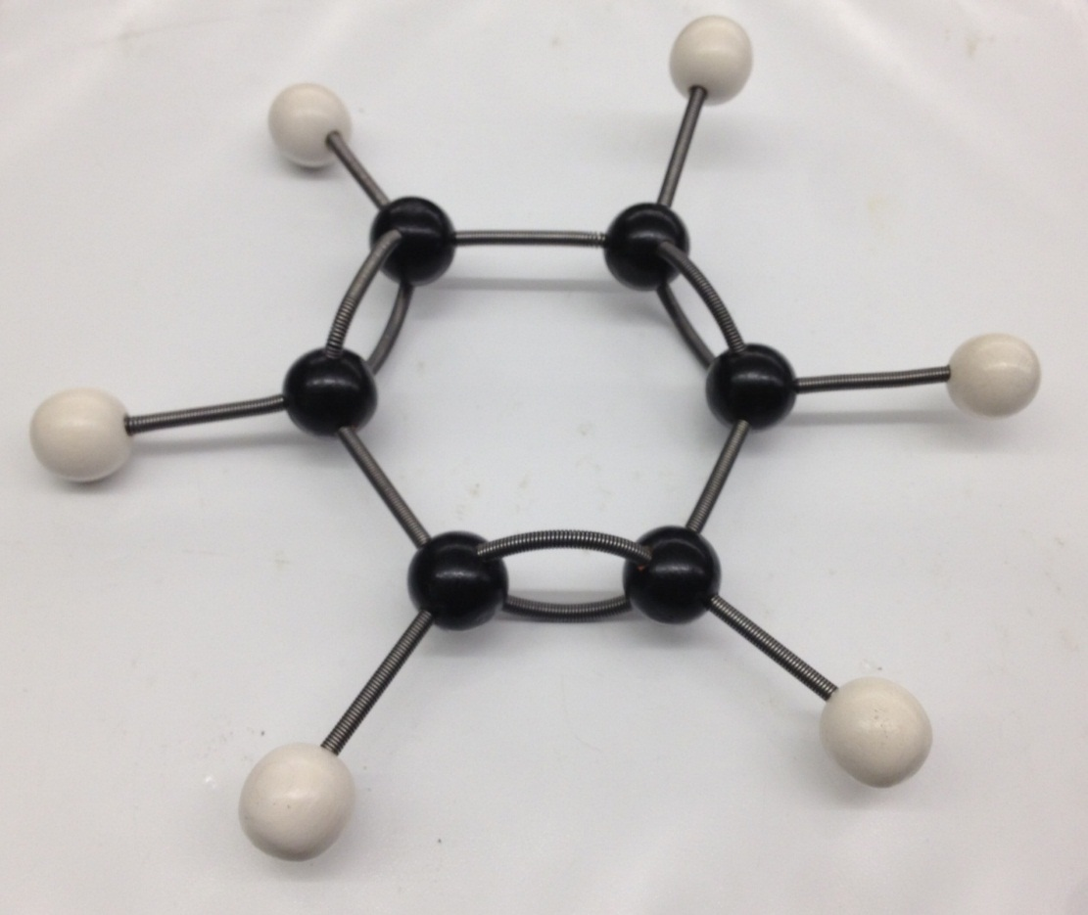
Charlotte Smith Hollingsworth and Michelle Lam | 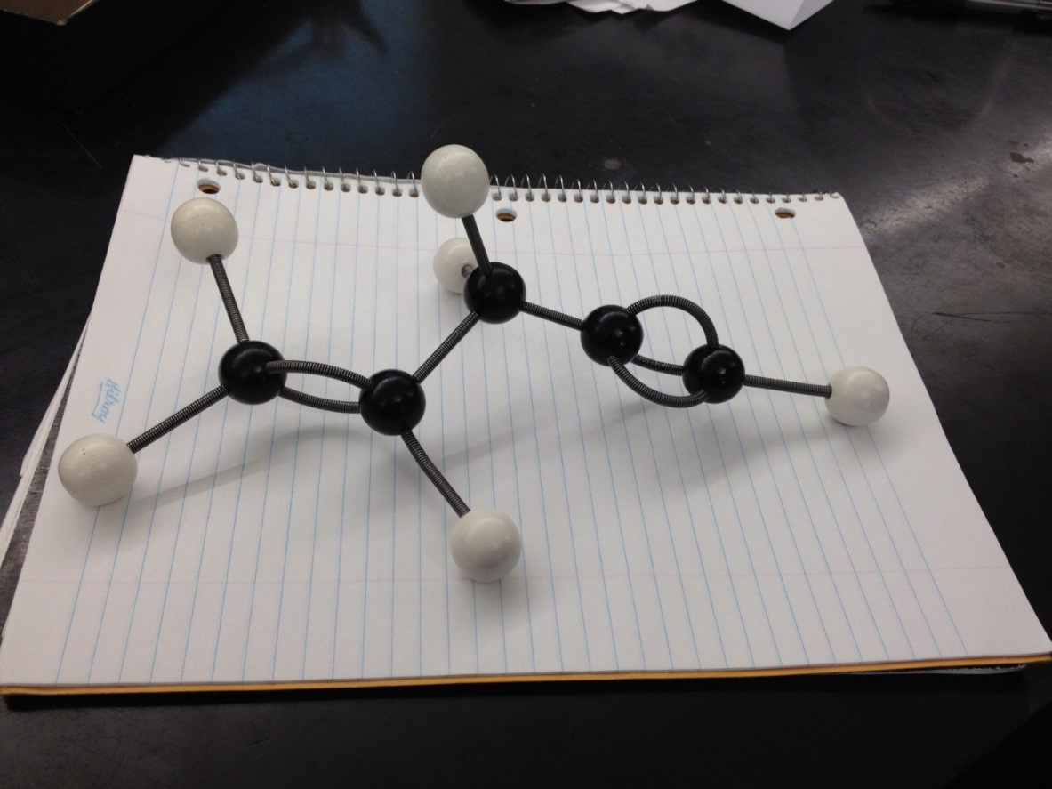
Sandy Wu and Monica Tsang | 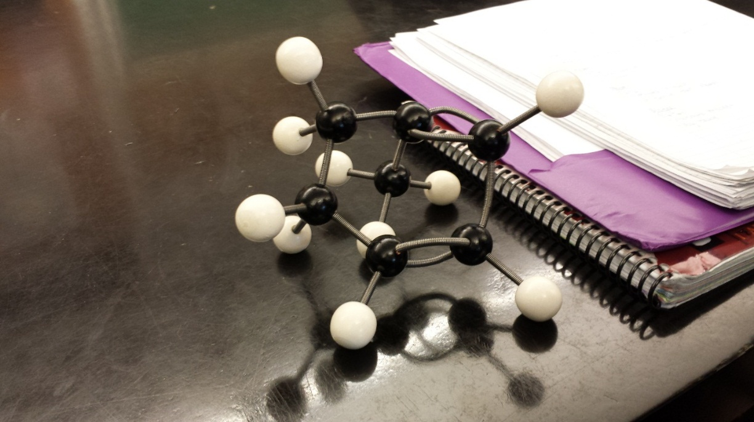
Jacky Lau and Sydney Parisotto | 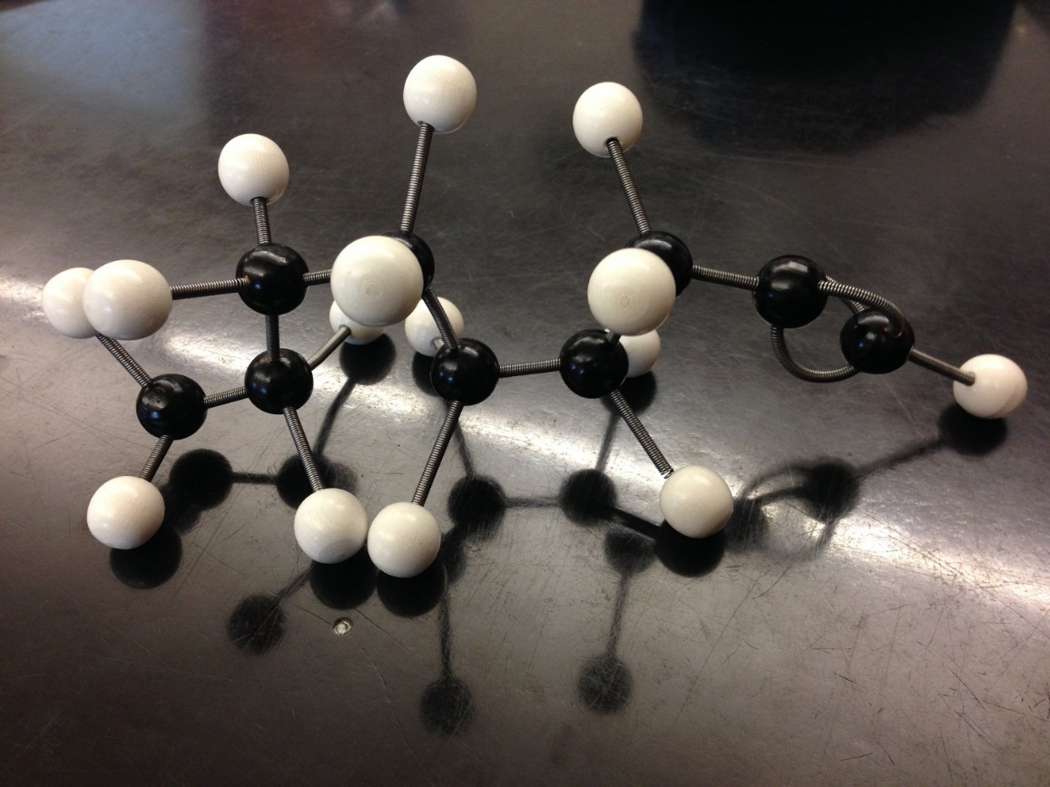
Sean Lam  Philip Mak | 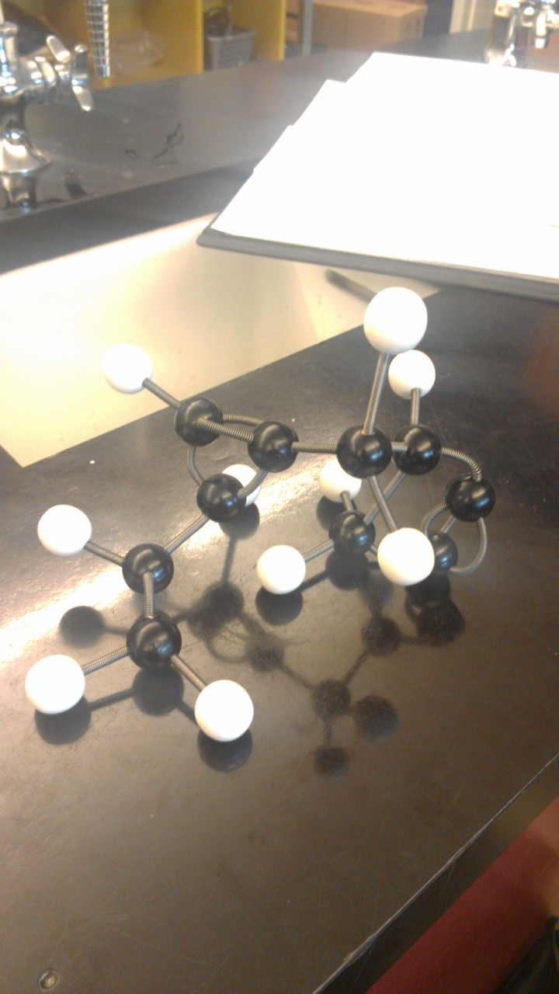  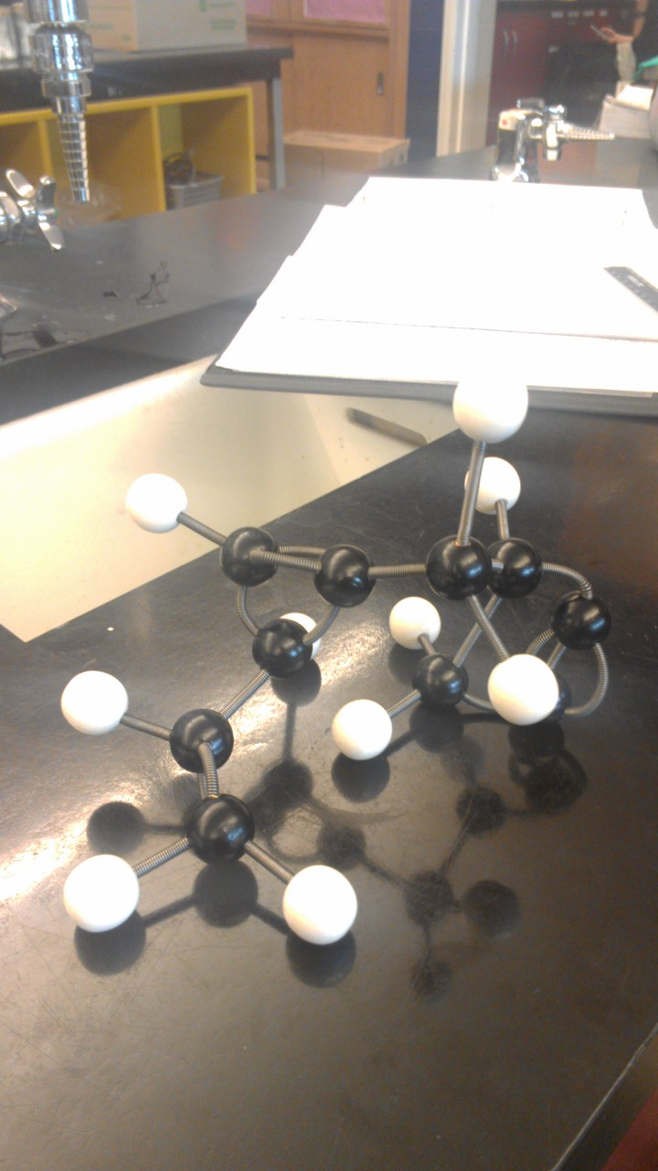
Rita Chou, Melanie Ng Blk G | 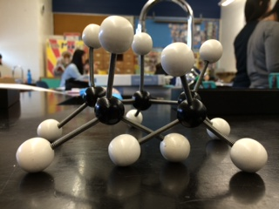
Davis Pham and Alvin Cheng | 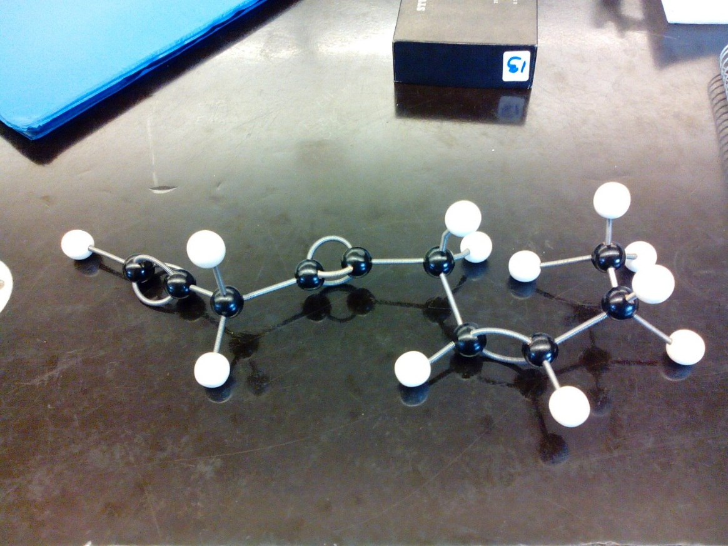
Catherine Wu  Gloria Peteran | 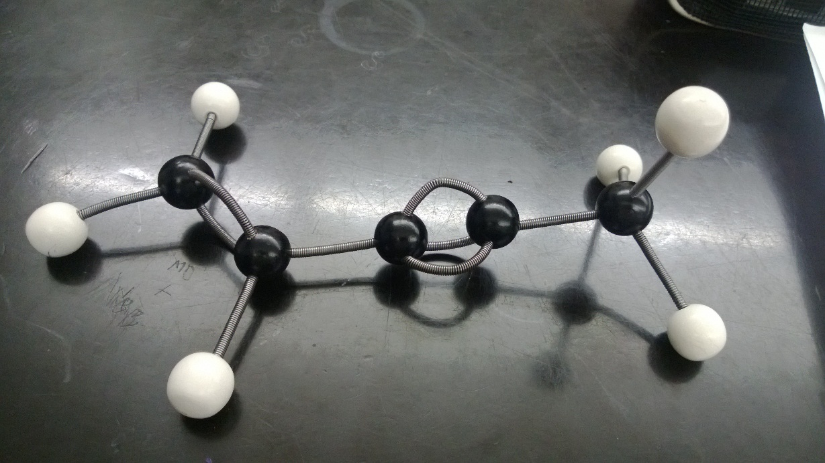
Janine lee and lily lai | 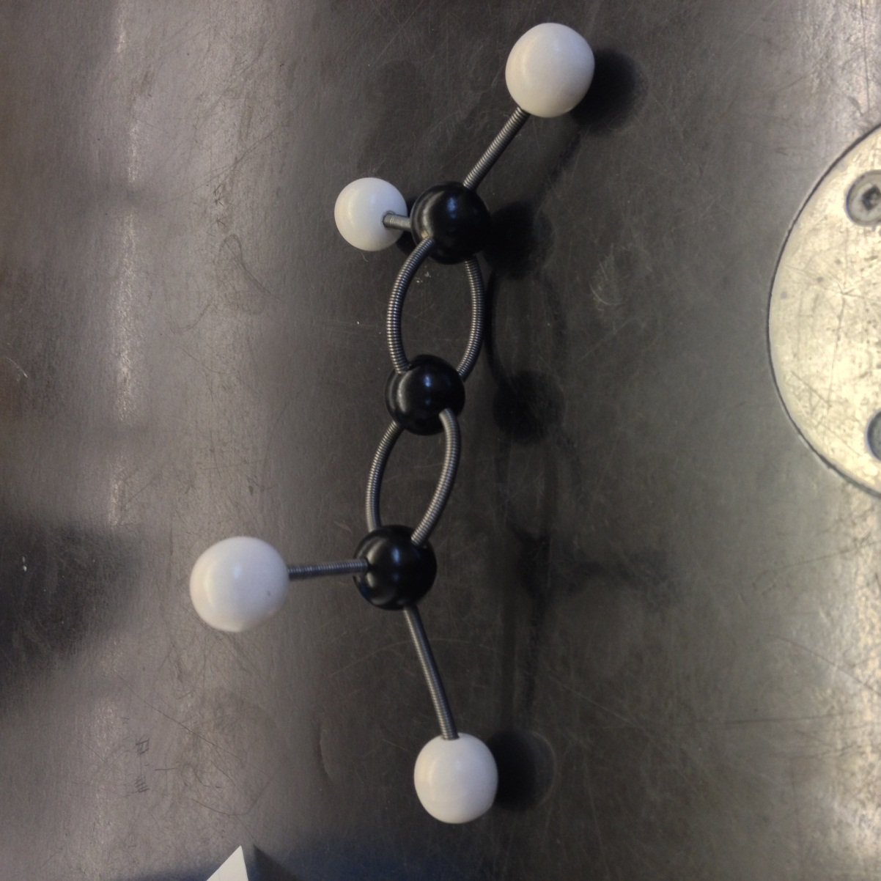
Block G:Jim, Denny | 