Block G
Students | Molecule
Yasmeen vaquerano, caroline wu, winter stacey | 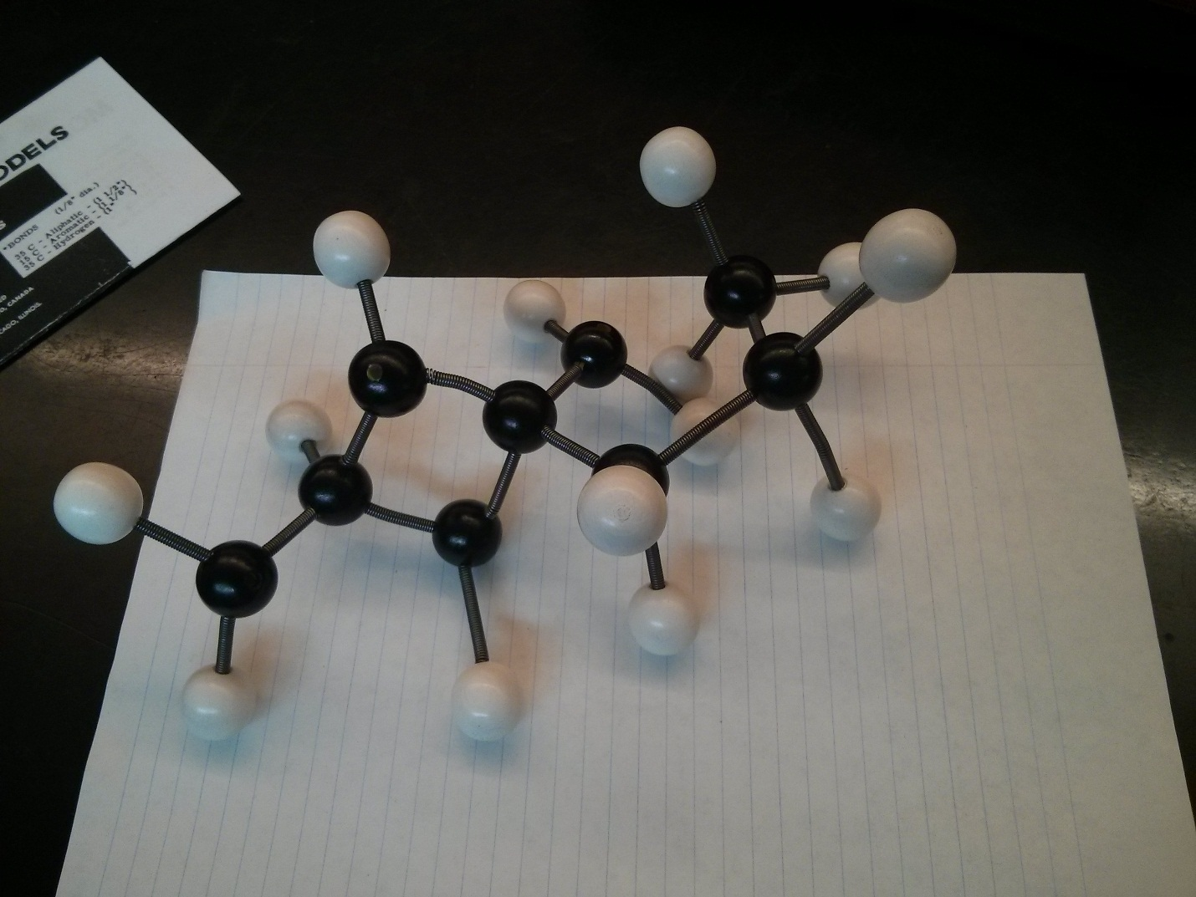
Joanne Chu, Jennifer Lin | 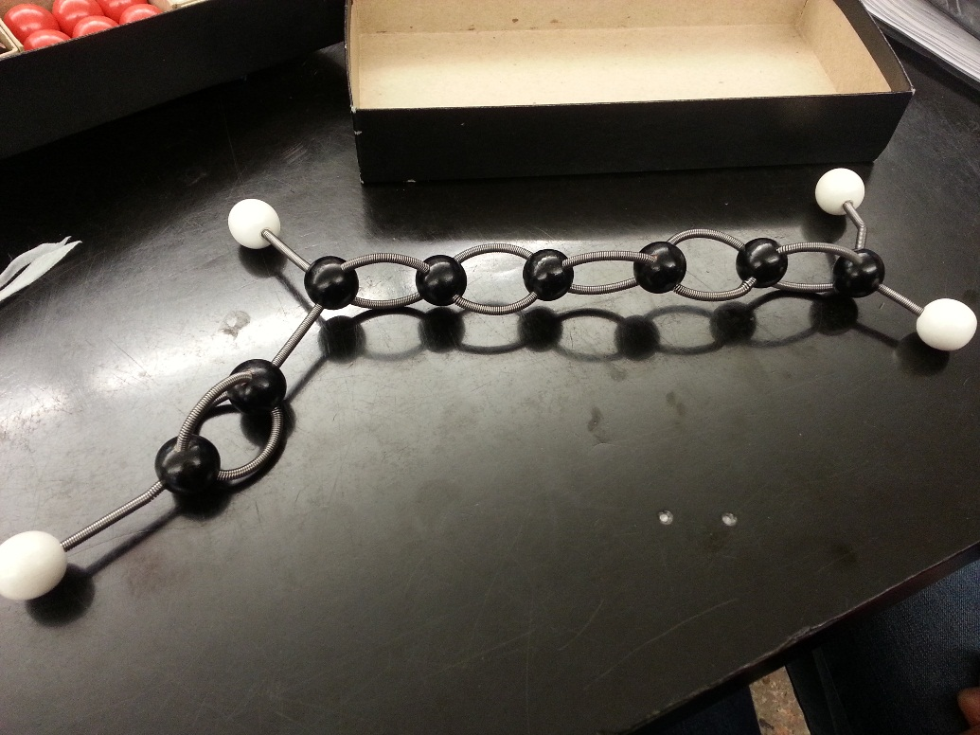
Janice Zuo  Mary Cao  Mimi zhang | 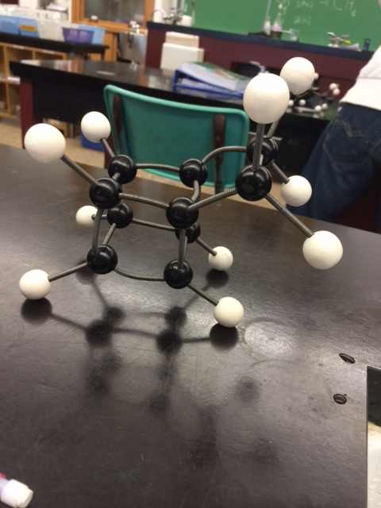
Justin Phan  Justin Javellana  Alvin Macalalad | 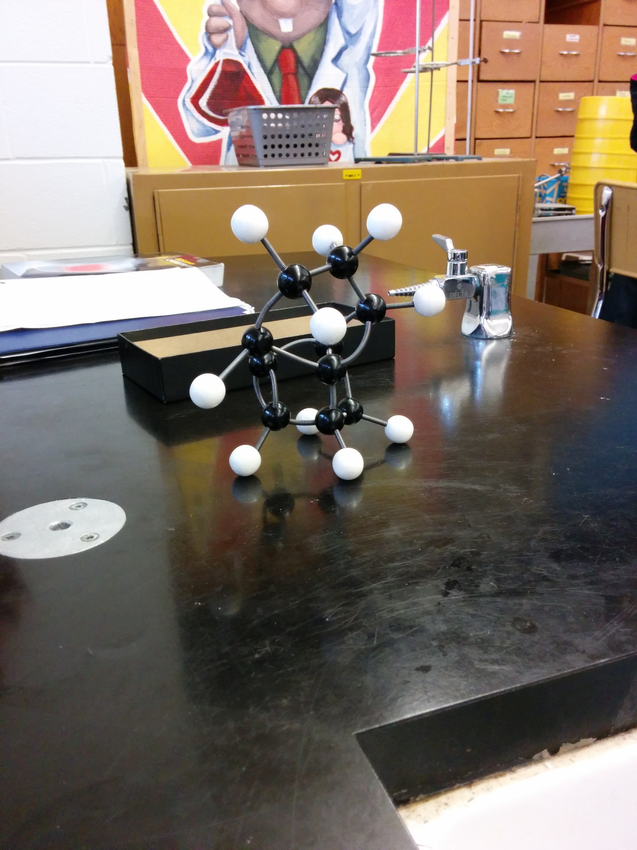
Kaitlyn Truong & Winnie Jin | 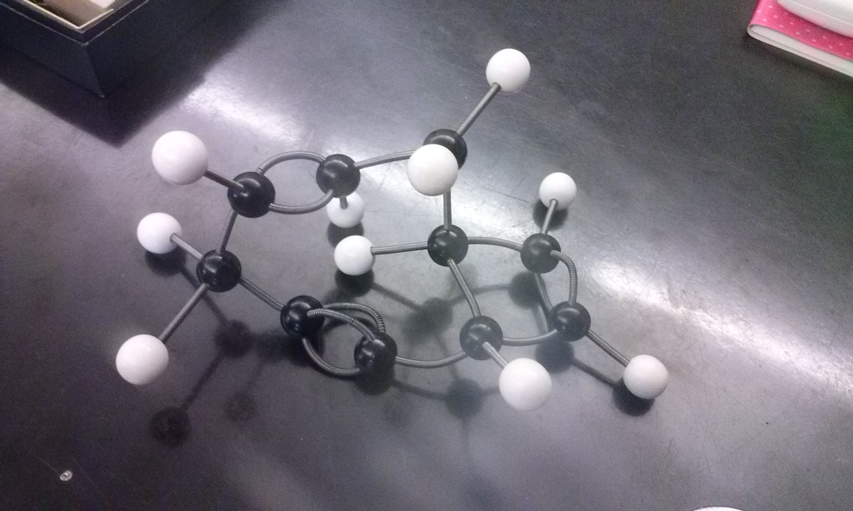
Yulinda Fang | 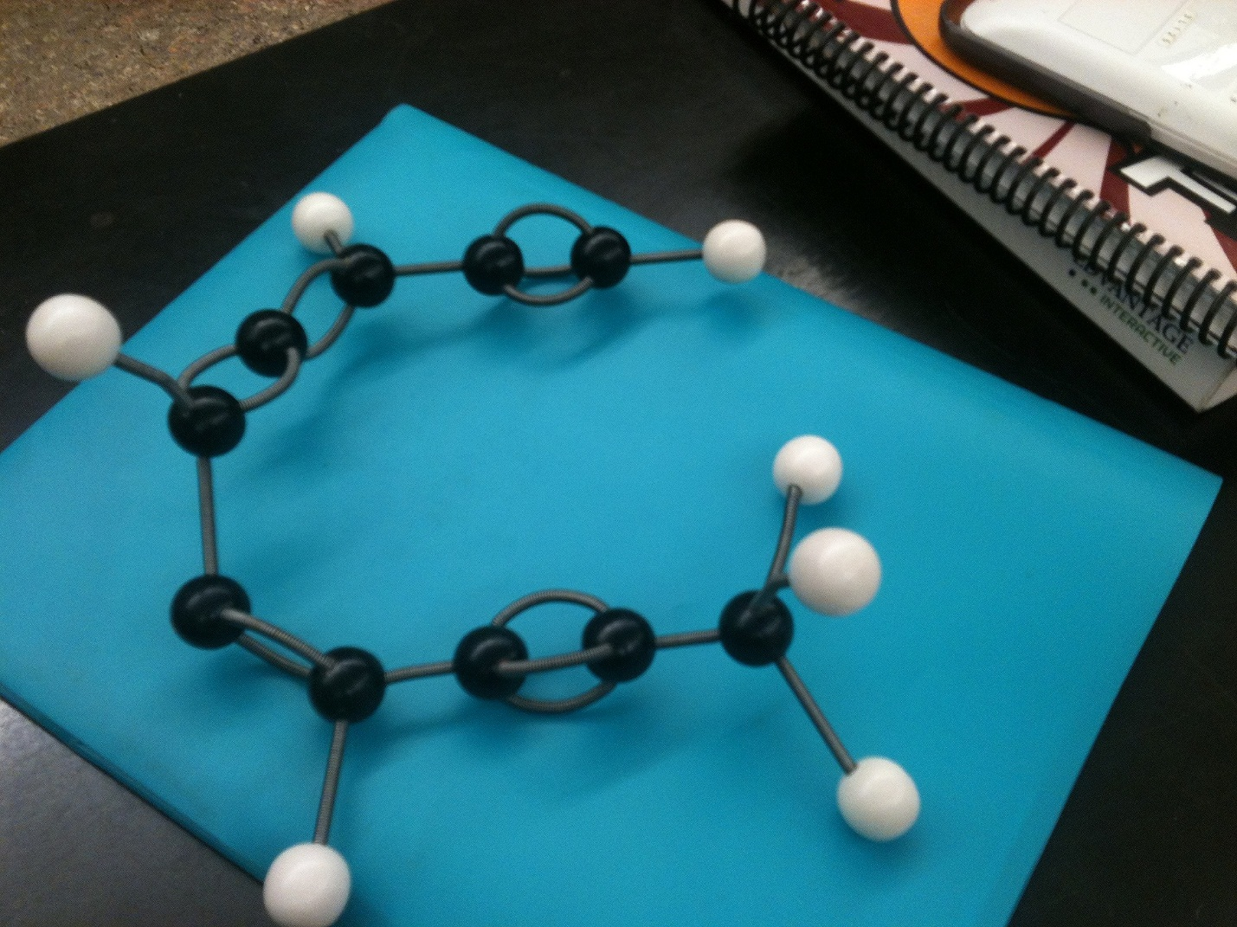
Andy Chen, Anthony Wong, Gladstone Ma. | 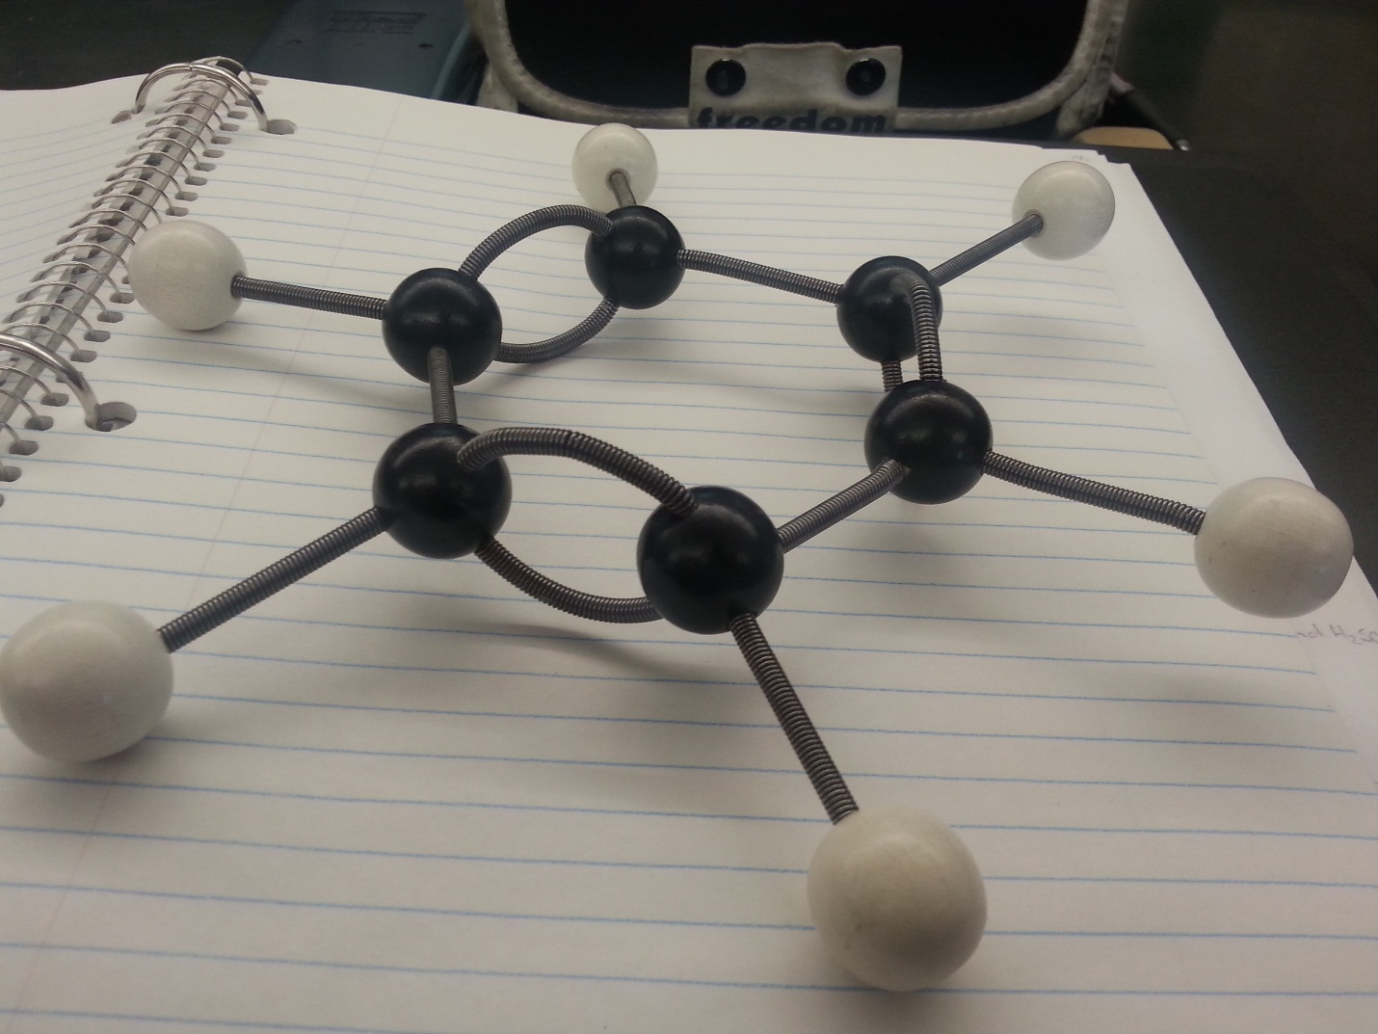
Kelvin Lai and Kenny Wu | 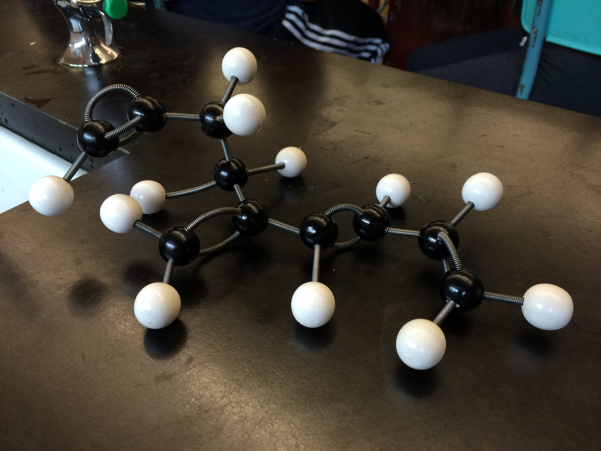
Susanna Yip  Yulinda Fang | 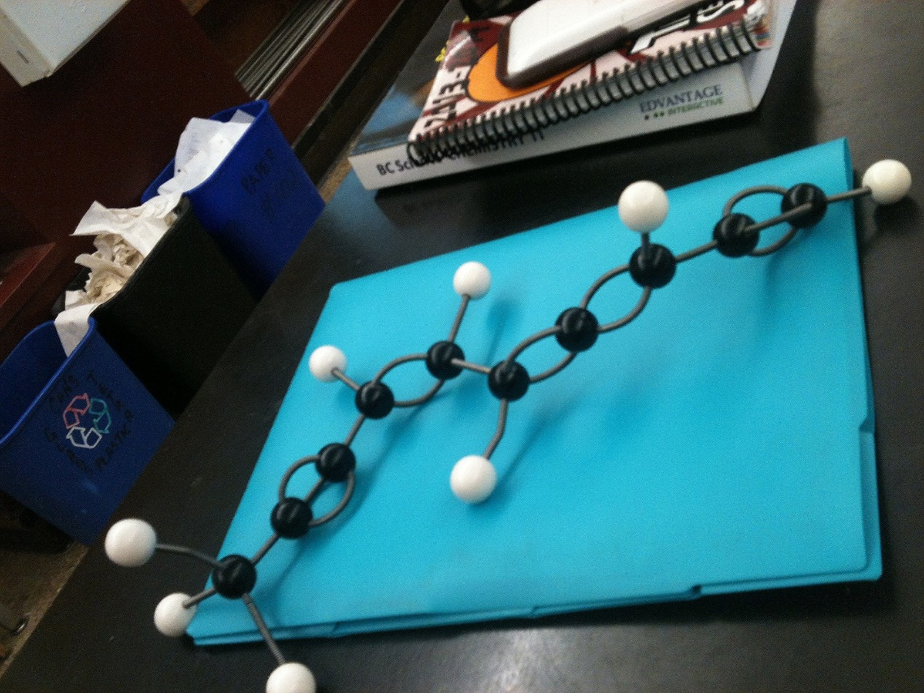
Yolanda you Jackie Zhong Charles Yu | 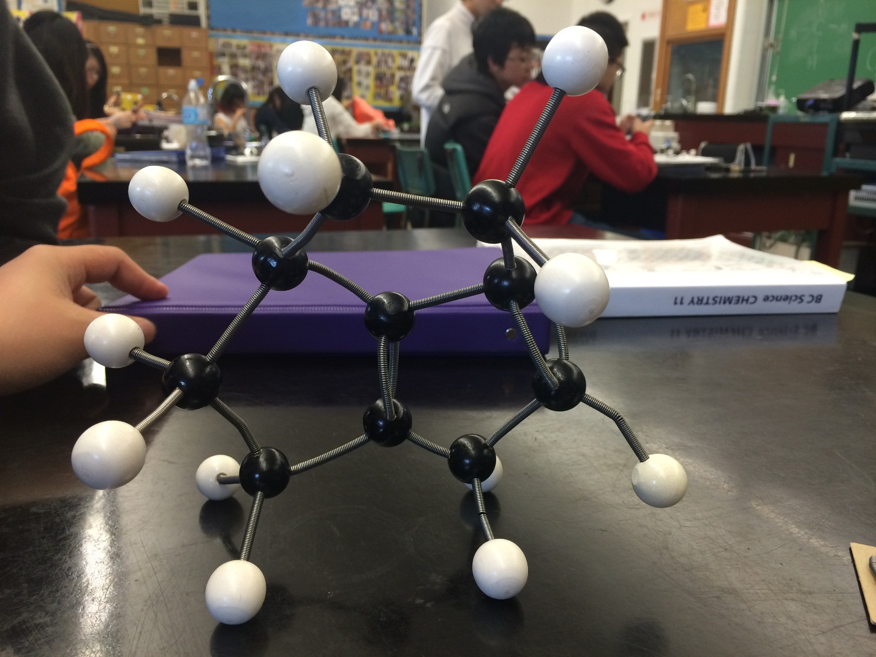
emily ma & janice esguerra | 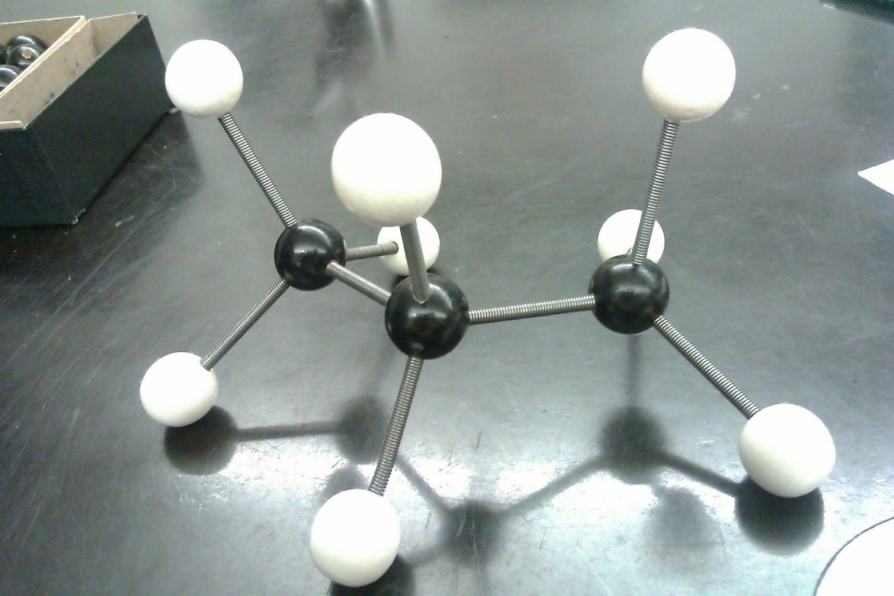
Jen and Christina's Blk E | 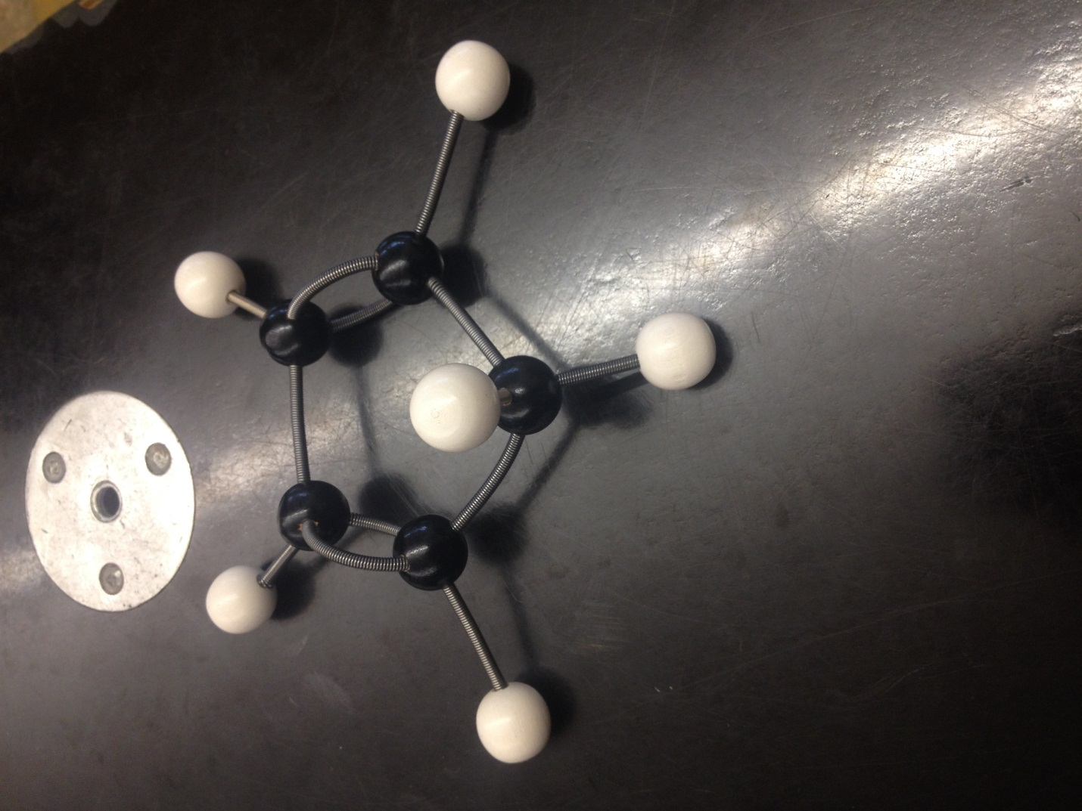
Anna Chee and Lucy Hoang Blk E | 